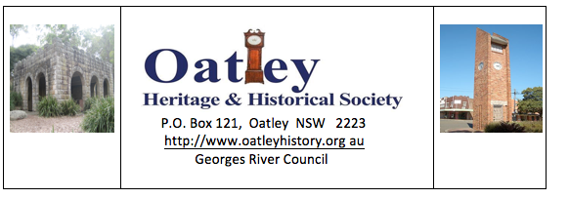

March 2020 Newsletter.

As I write my first OHHS Newsletter as your President, I feel a bit like Winston Churchill must have felt in 1940 when he became British Prime Minister. Life looks very dark at the moment for all of us, especially the more senior of our population with no light at the end of the tunnel. We can only hope that we all get through the current crisis and that our Society’s activities will return to normal sooner rather than later.

In view of the present situation, we have cancelled the Coffee and Chat planned for Friday April 24th 2020 and we will let you all know nearer the date whether Cliff Crane’s presentation on Judge Nield will proceed at our scheduled meeting at Oatley RSL on 29th May 2020.

Before I proceed further, I wish to pay tribute to our past President Julian Sheen for his tremendous work and untiring endeavours on our behalf over the past five years. He is a very hard act to follow and I think we all owe him a tremendous vote of thanks for all he has done for OHHS in the past five years.
THANK YOU Julian!

Next I want to especially thank Ros Ingram for her terrific presentation on the life of James Oatley following our AGM on 28th February. Many people who were at that presentation have commented to me and other Committee members how much they enjoyed her presentation and how much they learned about James Oatley.

With Regards to our plaques program there are two projects currently underway. Firstly Julian Sheen has been exploring with Georges River Council, the possibility of placing some kind of plaque on Searchlight Lane which is off Baker Street Oatley West near the cluster of shops at that location. A Searchlight was located there during World War II and the Society considers it would be appropriate to have a plaque at that location. Secondly, Julian has also been exploring the possibility of having a plaque on the small plot of land on the corner of Douglas Haig Street and Gungah Bay Road to mark the Robert Townson’s land grant that included land to the west of James Oatley’s Grant.

Julian is also hopeful of doing a presentation on Robert Townson at our meeting on 21 August(note this date is a week earlier that is shown in the 2020 Oatley Calendar).
Finally I should welcome our new Committee for 2020 who were elected at our AGM.

President Lawrie Yeomans
Vice Presidents Julian Sheen and Graham Lalchere
Secretary Rodger Robertson
Treasurer Geoff Ingram
Committee Kim Wagstaff, Bill Wright, Carol Harland, Graham Murphy, Cliff Crane, Norm Windred, Lance Westfallen, Pam Donnet.

We owe a special vote of thanks to Bill Wright for his untiring work as Secretary for the past seven years and I am very pleased that he has decided to remain on the Committee.

One difference this year will be that all email correspondence will come from our Secretary Rodger Robertson rather than from the President. If you do wish to contact me by email then my address is lyeomansmail@hotmail.com. I will respond to all communications.

Stay well

Lawrie Yeomans

President

