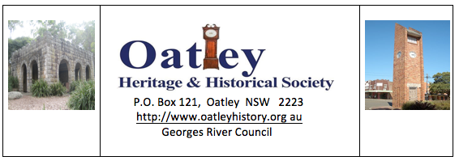

May 2020 from the Committee

Hello OHHS members- the following is a message from Lawrie Yeomans.
In view of the ongoing corona virus difficulties the Committee has decided to cancel the presentation planned for Friday 29 May. Further advice will be provided to members around mid July as to the holding of future meetings which will be dependent on Oatley RSL reopening AND allowing meetings to be held. The Committee hopes all members are safe and well in these difficult times and we look forward to resuming our usual activities as soon as possible
Rodger Robertson
Hon Sec

0408232874

