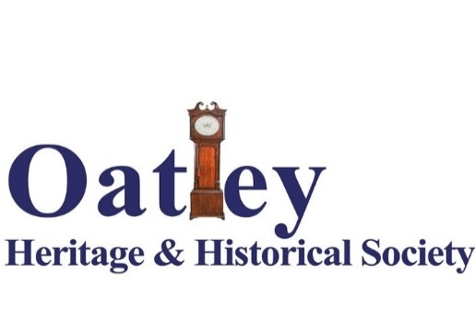
P.O. Box 121, Oatley NSW 2223 http://www.oatleyhistory.org.au
OHHS Newsletter October 2019
As you can see we have adopted the above image as our logo to appear on all our documents and publications. When you see it you will recognise that you are home with one of James Oatley’s clocks at OHHS. The logo was designed by Shaun Keays-Burn who has been responsible for much of the work on our current and forthcoming (2020) calendars. Shaun has again done a great job, thank you sir.
I expect you will find the logo on our newly purchased banner to be unfurled at the Oatley lions Festival. I think it is a noble design in an attention getting colour. By the time you receive this newsletter the Festival may have been held. I hope you had a chance to call by our stall (No.585) and said hello.
If you have not done so don’t forget to buy one or more Oatley 2020 calendars sponsored this year by OHHS. With Shaun, Rodger Robertson did much the text preparation.
We have our last Coffee & Chat of the year coming up on Friday 25th August. The gathering will take place as usual in the RSL hall starting at 10am. Features will include an introduction to the themes of the latest calendar by Rodger , an input from Graham Lalchere on the historic Lugarno property Glen Lea and an Oatley trivia quiz led by Geoff Ingram (actually, he assures me, there is nothing trivial about Oatley). And of course there will be ample opportunity to exchange reminiscences about the history and heritage of Oatley. Plus, the coffee and biscuits are free… irresistible. We are trying to dispense with environmentally damaging Styrofoam coffee cups so if you can bring a spare coffee mug with you, you can leave it at the kitchen for next time.
At our last presentation session for the year (Friday 22nd November) Bob Drake will talk about the oyster industry in Oatley, a fascinating topic, don’t miss it. Before the presentation starts there will be a brief special meeting to address a number of constitutional issues which have been considered and supported by the committee. The committee believes there is nothing controversial in these changes which are more a matter of bringing our constitution in line with state requirements.
We are looking forward to next year, our 25th anniversary. I expect our silver anniversary will be marked late in the year. Plans are being developed for this. But if you have a good idea for a speaker or topic for either our May or August presentations please let me know; and if you think of other ways we can celebrate this significant milestone again, please let me know.
Oatley should soon have a new historic marker outside the Oatley library/ School of Arts building. This is a joint project between OHHS and Georges River Council. Watch out for it, it will be suitably large.
Julian Sheen

